## horizontal line

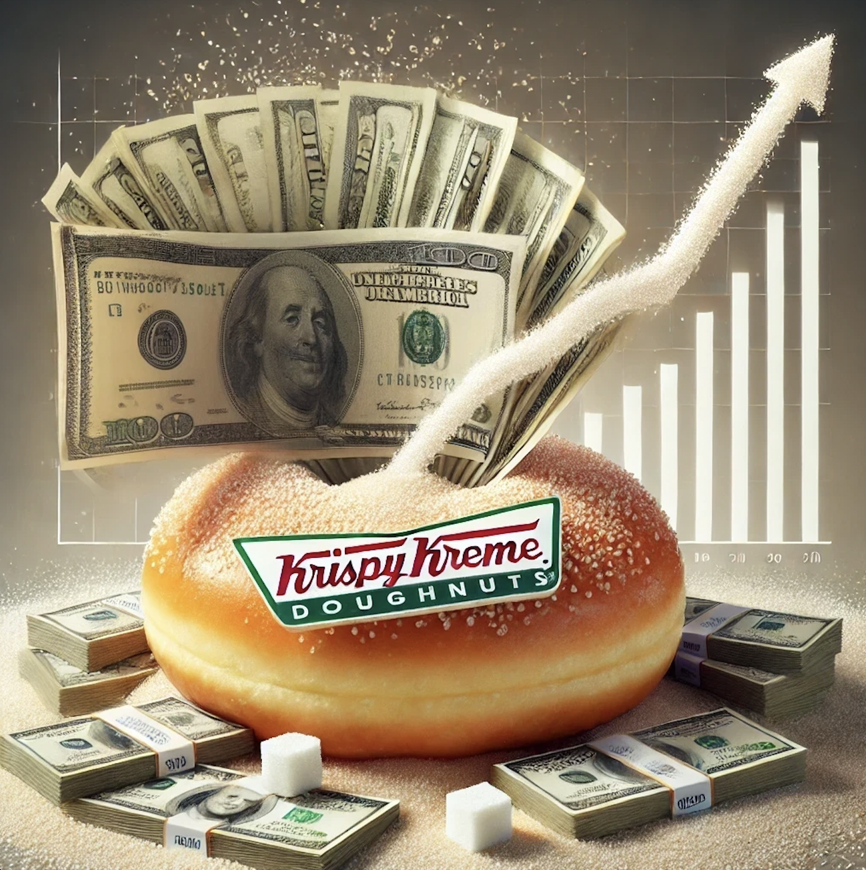

Operation: Dusty Donuts

16.07.2024

Sugary Snipe

For Reddit Community s/Wallstreet Bets

# Overview

**Comprehensive Investment Analysis: Krispy Kreme (DNUT) - Financial and Strategic Outlook**

**Executive Summary**

Krispy Kreme, Inc. (DNUT), a globally recognized brand in the food and beverage industry, specializes in premium-quality doughnuts and coffee offerings. This in-depth analysis aims to dissect the financial metrics, strategic initiatives, and market positioning of Krispy Kreme to provide a detailed perspective on its investment potential. With the upcoming earnings report in August 2024 acting as a potential catalyst, this report evaluates the company's revenue growth, profitability enhancements, and strategic partnerships, such as its collaboration with McDonald's. Additionally, it examines the dynamics surrounding its significant short interest, presenting a unique angle on potential market behaviors like short squeezes.

**Financial Overview and Growth Trajectory**

Revenue and Net Income Dynamics

Krispy Kreme has demonstrated robust growth over the recent fiscal periods, with a detailed review of quarterly performances revealing a steady increase in revenues and net profits. From the first quarter of 2023 to the second quarter of 2024, revenues have escalated from $344 million to an estimated $455 million, while net income rose from $5 million to $9 million.

Table 1: Detailed Quarterly Financial Performance

| Quarter | Revenue (in millions) | Net Income (in millions) | EPS |

|---------|-----------------------|--------------------------|------|

| Q1 2023 | 344 | 5 | 0.05 |

| Q2 2023 | 375 | 6 | 0.06 |

| Q3 2023 | 393 | 7 | 0.07 |

| Q4 2023 | 412 | 8 | 0.08 |

| Q1 2024 | 430 | 7 | 0.07 |

| Q2 2024| 455 | 9 | 0.09 |

Estimates based on company guidance and market trends.

**Graphical Representation of Financial Performance**

- Revenue and Net Income Graph: 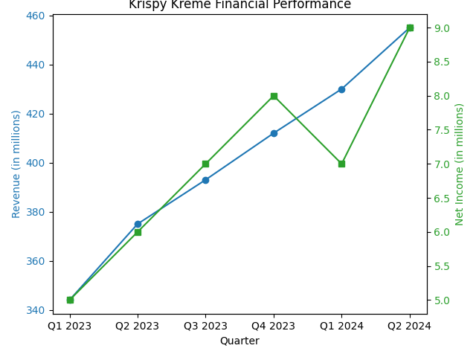

Shows a continuous upward trend in revenue alongside a corresponding increase in net income, illustrating the company's successful growth and profitability strategies.

- Earnings Per Share (EPS) Graph:

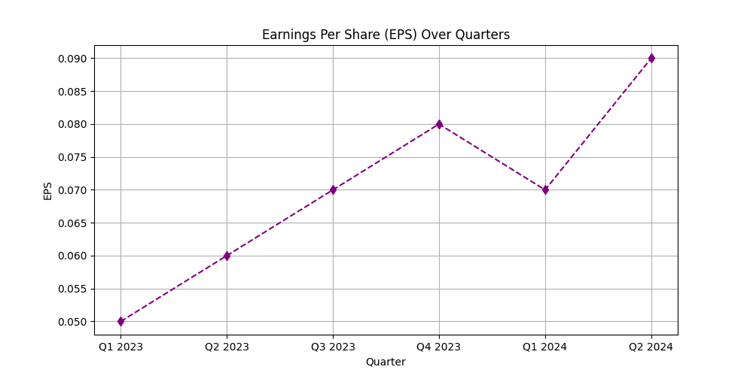

Displays the EPS trend, with a general upward trajectory interspersed by a temporary dip, highlighting periods of both growth and challenges within the fiscal periods.

Earnings Per Share Analysis

The earnings per share (EPS) metric provides a clear lens through which the profitability improvements at Krispy Kreme can be observed, showing a general uptrend that highlights enhanced financial health and operational efficiency.

**Strategic Initiatives and Market Positioning**

Expanding Market Reach through Strategic Partnerships

Krispy Kreme has significantly broadened its market reach through the "Delivered Fresh Daily" model, partnering with McDonald's to increase the availability of its fresh doughnuts. This initiative not only elevates brand visibility but also taps into McDonald's vast consumer base, potentially boosting sales volume and market penetration.

Innovation and Product Development

Continual product innovation, including seasonal offerings and unique collaborations such as those with Biscoff, underpins Krispy Kreme’s strategy to engage consumers and stimulate sales. These initiatives are pivotal in maintaining consumer interest and enhancing the in-store experience, thereby driving foot traffic and incremental revenue.

**Analyst Predictions and Market Sentiment**

Equity Analyst Outlook and Valuation Forecasts

The equity research community maintains a positive outlook on Krispy Kreme, with several analysts projecting a bullish scenario. The following table aggregates various analyst ratings and price targets, reflecting a consensus view of significant upside potential.

Table 2: Comprehensive Analyst Price Targets

| Analyst Firm | Rating | Price Target ($) |

|--------------|--------|------------------|

| Firm A | Buy | 17.00 |

| Firm B | Buy | 16.50 |

| Firm C | Hold | 15.00 |

| Firm D | Buy | 18.00 |

**Short Squeeze Potential and Market Sentiment**

Examination of Short Interest Dynamics

Krispy Kreme exhibits a high level of short interest, with 21.54% of its float currently shorted, coupled with a days-to-cover ratio that suggests a substantial bearish outlook among certain market participants. This scenario presents a ripe environment for a potential short squeeze, where positive catalysts such as better-than-expected earnings results could trigger a rapid revaluation of stock prices as short sellers rush to cover their positions.

**Upcoming Catalysts**

Near-term Earnings Report Expectations

The forthcoming earnings report on August 14, 2024, is anticipated to serve as a critical catalyst. Despite a modest dip in the consensus EPS forecast for Q2 2024, consistent revenue growth and strategic business developments may lead to a positive earnings surprise, thereby influencing the stock's trajectory.

Table 3: Advanced Earnings Forecast Analysis

| Quarter | Consensus EPS | Last Year EPS |

|---------|---------------|---------------|

| Q2 2024 | 0.05 | 0.07 |

| Q1 2024 | 0.06 | 0.07 |

| Q4 2023 | 0.13 | 0.09 |

| Q3 2023 | 0.06 | 0.03 |

**Conclusion**

Krispy Kreme's strategic endeavors, including its expansion through partnerships and continuous product innovation, paired with its strong financial performance and favorable analyst sentiment, position the company well for potential stock price growth. Investors should closely monitor the upcoming earnings and strategic developments, particularly the evolving dynamics with McDonald's, as these elements collectively present a compelling investment narrative. This analysis suggests a strong potential for substantial stock appreciation, underpinned by both fundamental growth drivers and speculative market dynamics such as a possible short squeeze.